# HTML syntactical rules

## Syntactical rules

Parsing through code syntactical rules should be able to be identified.

Logic would be to start parsing through this and make sense of it with the given doctype.

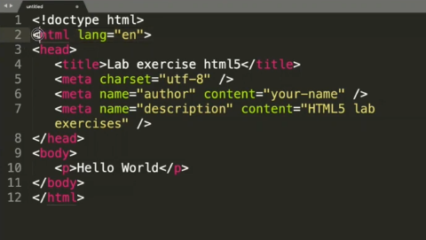

Examine 1st character. Recognise syntax and logic.

1. If it is a special character like < then you would expect valid element name to follow.
2. There is a parent child node relation.
3. Keep reading character until a particular condition happens. <html lang=”en”>

The space in-between html and lang is a delimiter. This allows the rest of the syntax to follow. The next syntax is an attribute (Lang).

1. (lang)Valid attribute within the doctype
2. = Another delimiter, this time an assignment.
3. “” open and closed quotation with an attribute inside of it.
4. > special character that closes off the tag.
5. </ end tag. Indicated by the /
6. /> self-closing element end of line 5. Does not have to be the full notation (<meta/>). Meta declares a value.
7. Line 6 where value attribute pair is repeated. Syntactical rule is that value attribute pairs with an = can be repeated.

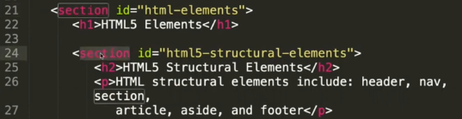

1. A parent could have a child of the same type, which Is nested. Section is a parent of one whole chunk of content. Within the section chunk, there is a child node of the same type(section).



1. Inputting special characters (£, $, @ etc.) similar to less than then an element that follows. You put & and finish with a ; and put a pneumonic for a character. To display a character, put it in as a special character, otherwise, the browser will think it is a special key word within the language.